Audio Design Document

In-Game Audio Patterns

1. Variation and Randomization

In our project we used many different footstep sounds (minimum three) from different free sources (e.g., freesound.org). For playback of sounds we are using the standard script for first person games from unity standard assets pack. This script has a feature that allows no sound to play twice in a row: It uses an array where zero index is reserved for storing the sound that was used during previous iteration and all other indices from 1 up to n-1 are used for storing available sounds for the current iteration. The sound for the current iteration will be randomly chosen using Random.Range-method.

1. Switches

Like in real life, our game world also has different footstep and landing sounds for different ground surfaces. In the outside area we have grass and concrete surfaces. As for the mansion, it has a wooden floor with carpets. Walking through the scene player proves with the script an area’s game object tag using Raycast and plays the suitable sound depending on the tag.

Figure 1 demonstrates main sound types and variations of these types:

**Figure 1**

1. States

Different game zones should be handled differently. So, when player enters the mansion, ambience should sound quieter, with less amount of high frequencies and footsteps should sound with more reverb. To set up the mansion borders we use few box colliders for each part of the mansion (we don’t use a mesh collider here because the mansion consists of many small meshes). Figure 2 illustrates collider set up:

**Figure 2**

For ambience and footstep audio groups we created two snapshots that represent outside and inside states. To determine whether player is inside or outside, we use a parameter “Counter” in script “Zone Controller”. Figure 3 illustrates main parameters for states control:

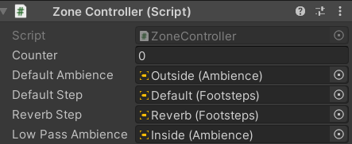

**Figure 3**

This counter is updated every frame and changes when player enters (incremented by 1) or leaves the collider (decremented by 1). Counter is equal to zero means that player is outside, otherwise player is inside the mansion.

1. Sequencing

We added an eerie sound sequence to enhance atmosphere of horror. It’s triggered when player enters the mansion by box trigger “SequenceTrigger”, placed in Villa2 game object. Script starts a coroutine that sequentially plays 3 spooky sounds. Also, when sequence starts, volume of background music will automatically fade out to 0 within one second. The script for correct fading was written by John French and published on his website.[1] To perform a smooth transition, sequence and background music are controlled by different audio sources. Figure 4 shows the trigger for the sequence:

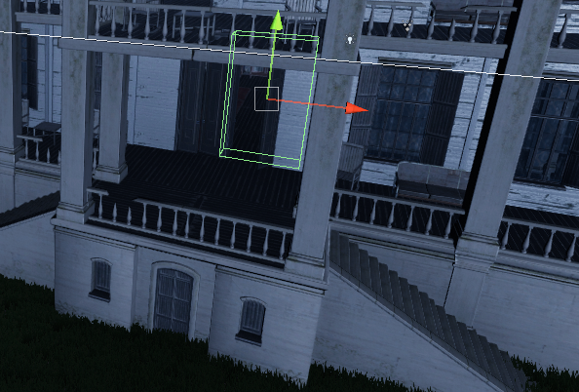

**Figure 4**

Menus and Gameplay

When player starts the game and goes to main menu, background music begins to play. As soon as the player press the play button, background music for main menu fades out and ambience with background music for game starts to play. Ambience music is just night forest record taken from freesound.org and cut with Pro Tools. Background music is called “Mosaic” by Yasuharu Takanashi, the music was also cut and cross faded in pro tools to avoid clipping when being looped.

If player press Escape and game is paused, the background music continues to play, but ambience sound doesn’t. In Pause Menu it’s possible to adjust volume of footstep sounds, background music and ambience sound. The logarithm value from slider is multiplied in script with factor 20 to correctly rescale master volume values.

Flashlight, that can be activated by pressing F, also has the sound of turning on\off.

After collecting each page, the tear off sound will be played.

1. https://gamedevbeginner.com/how-to-fade-audio-in-unity-i-tested-every-method-this-ones-the-best/